Test Case: tc002_SPX_Dev5_Crear_Requisicion_Spot_Con_FAD_Tipo_Cobro_CC
Step 1 - Enter username and password and click to button Enter : Credentials Entered
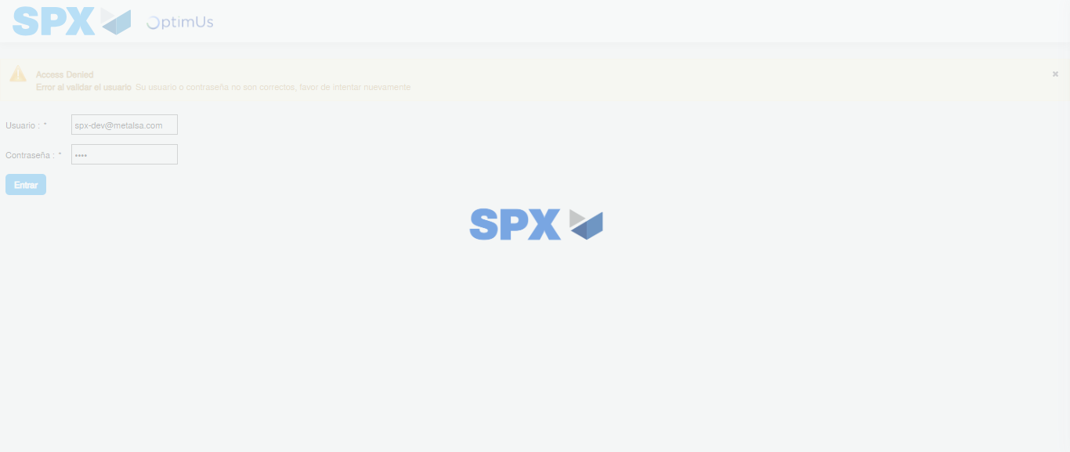Image file-name: QC_Testing-tc002_SPX_Dev5_Crear_Requisicion_Spot_Con_FAD_Tipo_Cobro_CC-1785975836788

Step 2 - Select to UEN and Access to Spot Buy Requisitions : UEN Correctly selected and Correct access
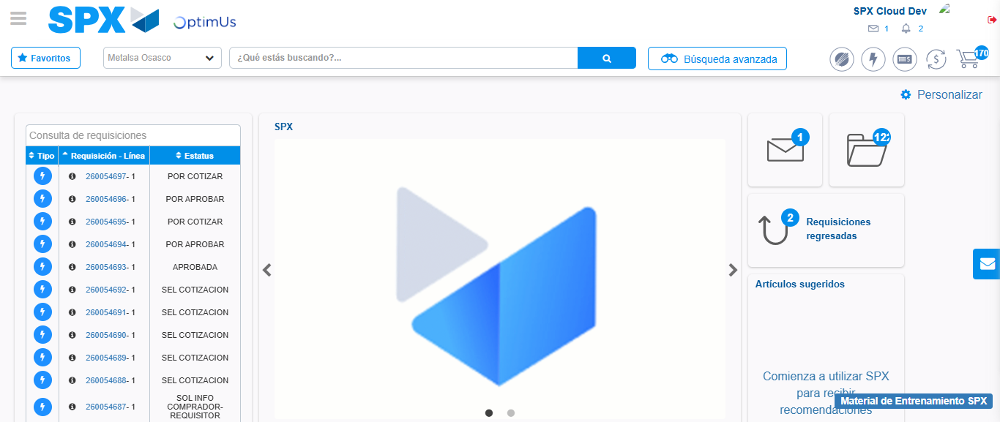Image file-name: QC_Testing-tc002_SPX_Dev5_Crear_Requisicion_Spot_Con_FAD_Tipo_Cobro_CC-1785975862864

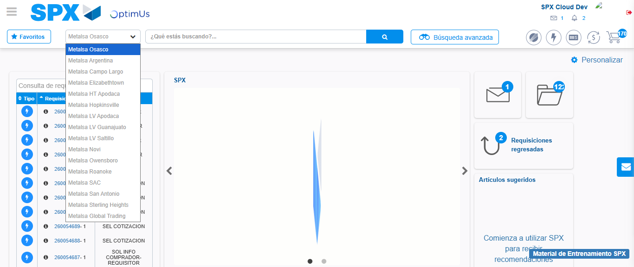Image file-name: QC_Testing-tc002_SPX_Dev5_Crear_Requisicion_Spot_Con_FAD_Tipo_Cobro_CC-1785975865762

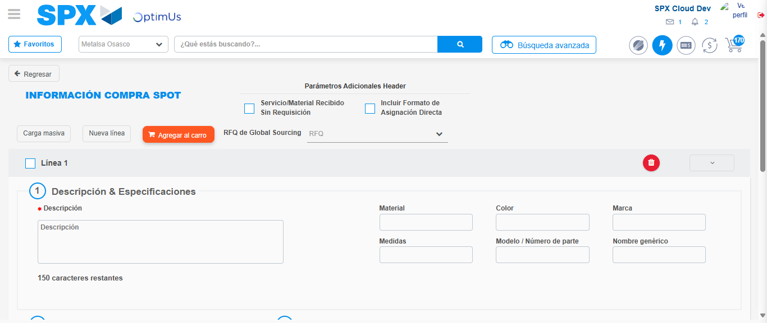Image file-name: QC_Testing-tc002_SPX_Dev5_Crear_Requisicion_Spot_Con_FAD_Tipo_Cobro_CC-1785975870678

Step 3 - Add FAD to Requisition: FAD Successfully Added
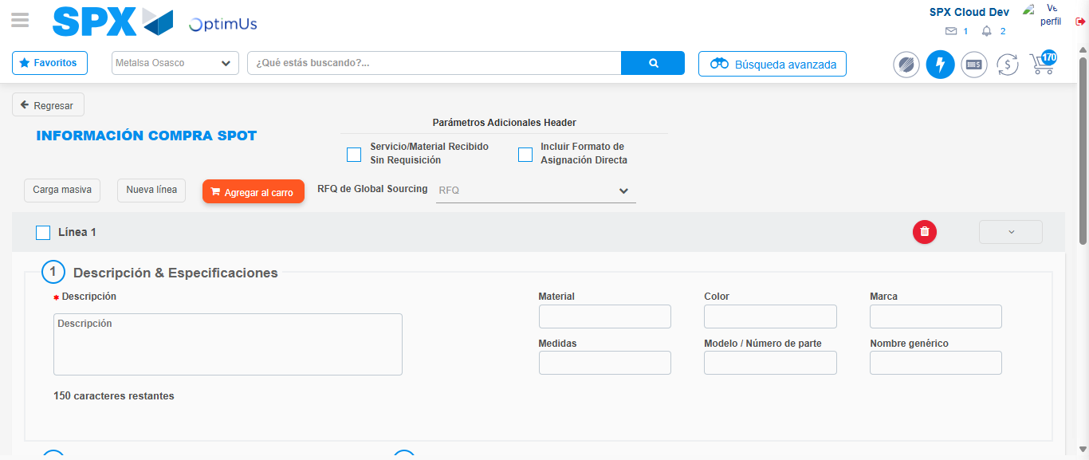Image file-name: QC_Testing-tc002_SPX_Dev5_Crear_Requisicion_Spot_Con_FAD_Tipo_Cobro_CC-1785975870977

Image file-name: QC_Testing-tc002_SPX_Dev5_Crear_Requisicion_Spot_Con_FAD_Tipo_Cobro_CC-1785975871192

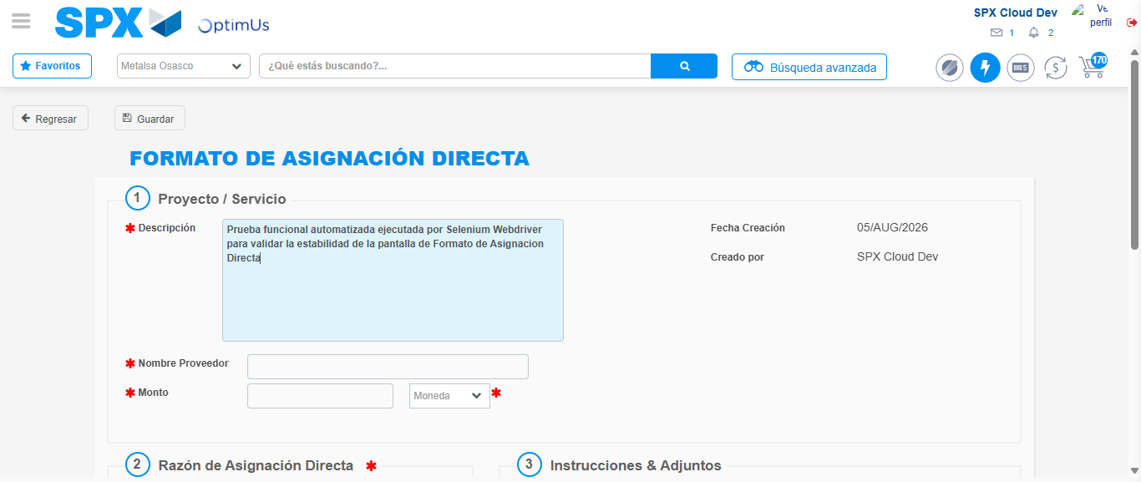Image file-name: QC_Testing-tc002_SPX_Dev5_Crear_Requisicion_Spot_Con_FAD_Tipo_Cobro_CC-1785975874169

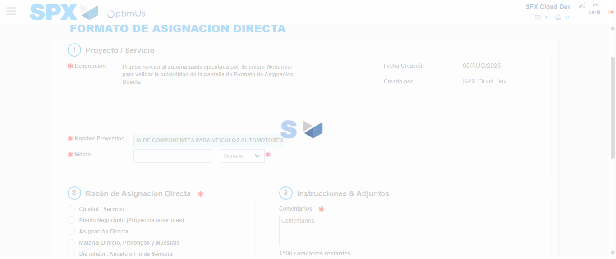Image file-name: QC_Testing-tc002_SPX_Dev5_Crear_Requisicion_Spot_Con_FAD_Tipo_Cobro_CC-1785975884800

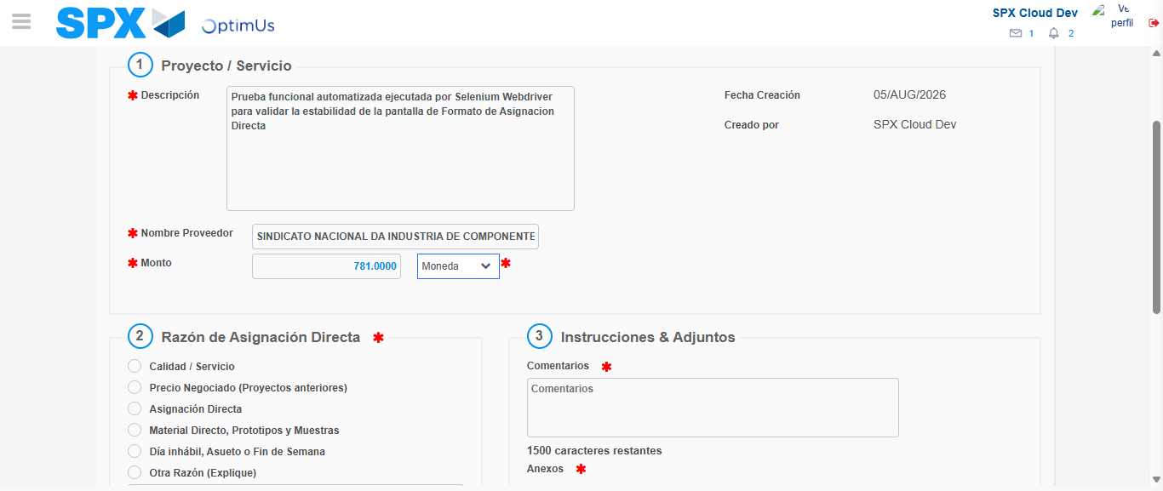Image file-name: QC_Testing-tc002_SPX_Dev5_Crear_Requisicion_Spot_Con_FAD_Tipo_Cobro_CC-1785975885337

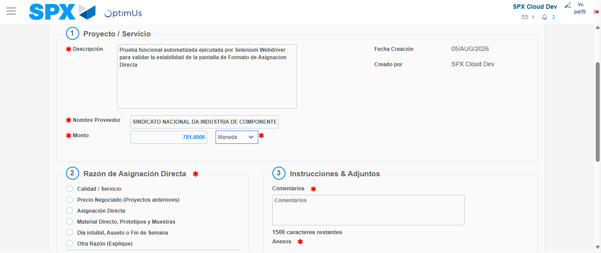Image file-name: QC_Testing-tc002_SPX_Dev5_Crear_Requisicion_Spot_Con_FAD_Tipo_Cobro_CC-1785975885555

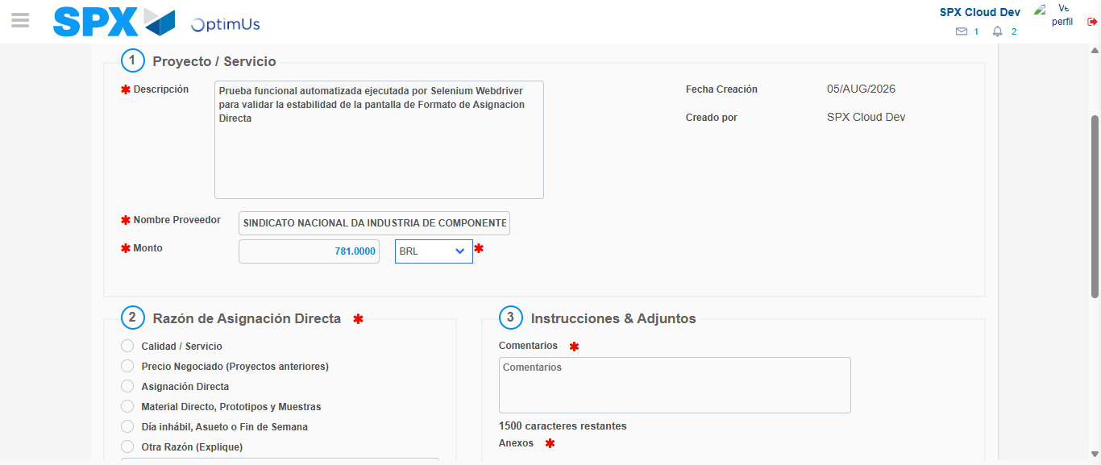Image file-name: QC_Testing-tc002_SPX_Dev5_Crear_Requisicion_Spot_Con_FAD_Tipo_Cobro_CC-1785975886087

Image file-name: QC_Testing-tc002_SPX_Dev5_Crear_Requisicion_Spot_Con_FAD_Tipo_Cobro_CC-1785975886371

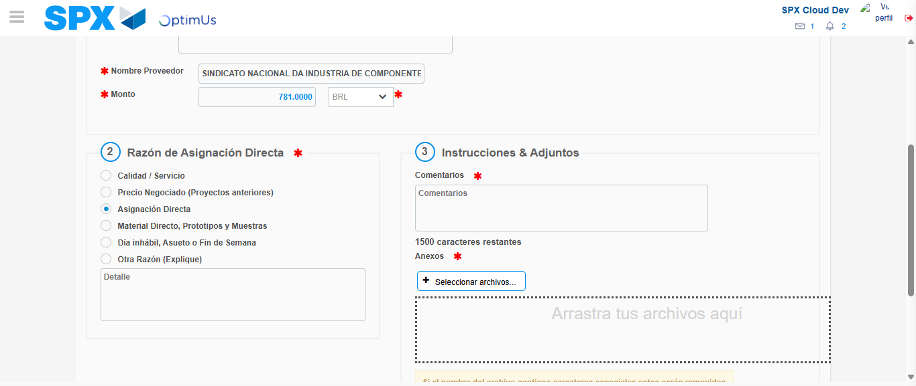Image file-name: QC_Testing-tc002_SPX_Dev5_Crear_Requisicion_Spot_Con_FAD_Tipo_Cobro_CC-1785975887298

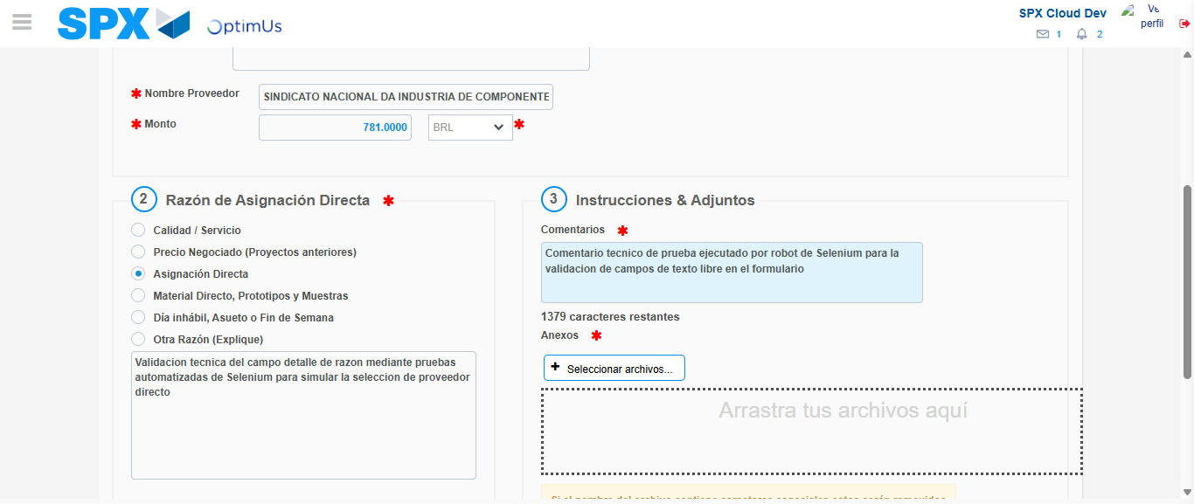Image file-name: QC_Testing-tc002_SPX_Dev5_Crear_Requisicion_Spot_Con_FAD_Tipo_Cobro_CC-1785975898831

Image file-name: QC_Testing-tc002_SPX_Dev5_Crear_Requisicion_Spot_Con_FAD_Tipo_Cobro_CC-1785975899666

Step 4 - Data Capture Spot Buy Requisition: Data captured correctly
Image file-name: QC_Testing-tc002_SPX_Dev5_Crear_Requisicion_Spot_Con_FAD_Tipo_Cobro_CC-1785975870977

Image file-name: QC_Testing-tc002_SPX_Dev5_Crear_Requisicion_Spot_Con_FAD_Tipo_Cobro_CC-1785975871192

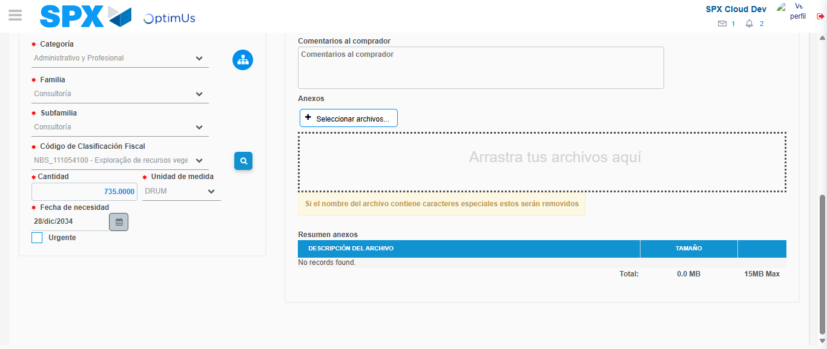Image file-name: QC_Testing-tc002_SPX_Dev5_Crear_Requisicion_Spot_Con_FAD_Tipo_Cobro_CC-1785975918656

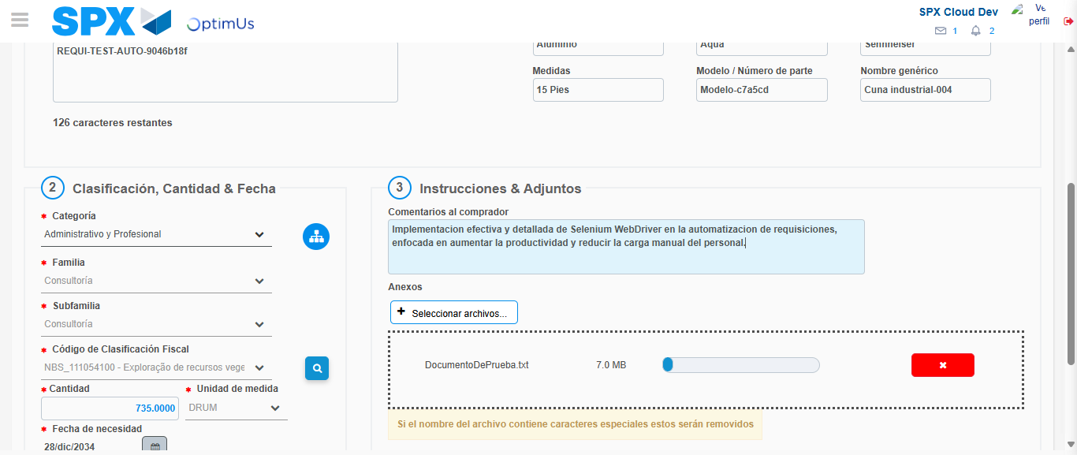Image file-name: QC_Testing-tc002_SPX_Dev5_Crear_Requisicion_Spot_Con_FAD_Tipo_Cobro_CC-1785975919659

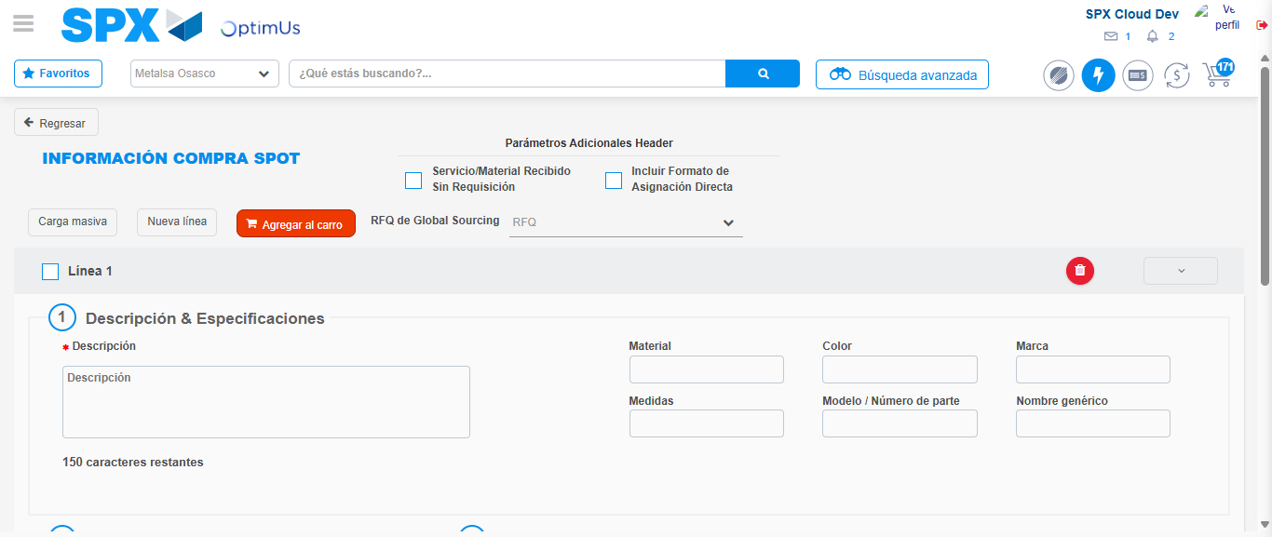Image file-name: QC_Testing-tc002_SPX_Dev5_Crear_Requisicion_Spot_Con_FAD_Tipo_Cobro_CC-1785975930104

Step 8 - Return to Main Page SPX : Return to Main Page SPX
Image file-name: QC_Testing-tc002_SPX_Dev5_Crear_Requisicion_Spot_Con_FAD_Tipo_Cobro_CC-1785975862864

Image file-name: QC_Testing-tc002_SPX_Dev5_Crear_Requisicion_Spot_Con_FAD_Tipo_Cobro_CC-1785975865762

Image file-name: QC_Testing-tc002_SPX_Dev5_Crear_Requisicion_Spot_Con_FAD_Tipo_Cobro_CC-1785975870678

Image file-name: QC_Testing-tc002_SPX_Dev5_Crear_Requisicion_Spot_Con_FAD_Tipo_Cobro_CC-1785975932368

Image file-name: QC_Testing-tc002_SPX_Dev5_Crear_Requisicion_Spot_Con_FAD_Tipo_Cobro_CC-1785975932559

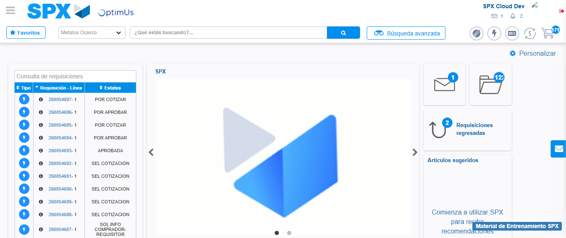Image file-name: QC_Testing-tc002_SPX_Dev5_Crear_Requisicion_Spot_Con_FAD_Tipo_Cobro_CC-1785975953994

Step 9 - Log Out : Log Out SPX
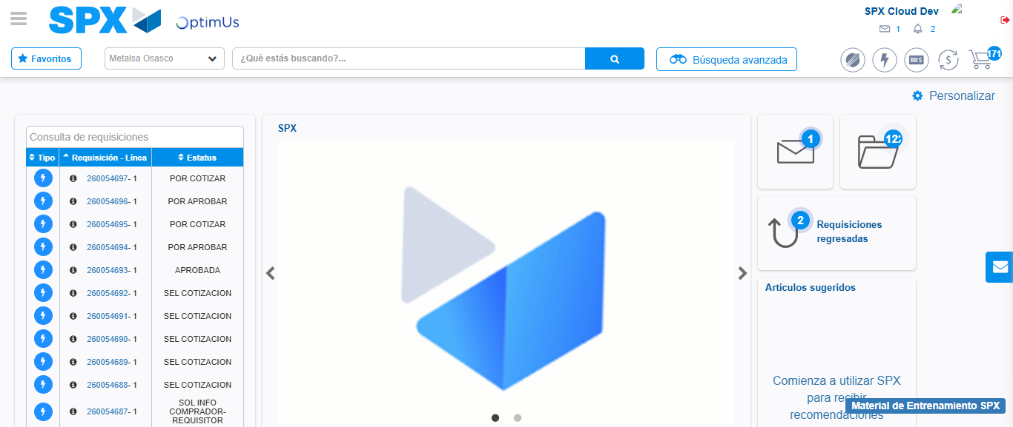Image file-name: QC_Testing-tc002_SPX_Dev5_Crear_Requisicion_Spot_Con_FAD_Tipo_Cobro_CC-1785975954324

